Python Project - Shreyas(1811049), Sanyam(1811040) & Parshva(1811046)

**File Manager**

User Manual

horizontal line

# 

# Introduction

We have created a local file manager using the modules tkinter and shutil. The local file manager has the following features such as creating a new directory, adding a new file, renaming a new file, deleting a file, copying a file, cutting and pasting a file.

## About the modules

### tkinter

Tkinter is a Python binding to the Tk GUI toolkit. It is the standard Python interface to the Tk GUI toolkit, and is Python's de facto standard GUI. Tkinter is included with standard Linux, Microsoft Windows and Mac OS X installs of Python. The name Tkinter comes from the Tk interface.

### shutil

The shutil module offers a number of high-level operations on files and collections of files. In particular, functions are provided which support file copying and removal.

## Functions

1. Creating a new directory:

Folder Before:

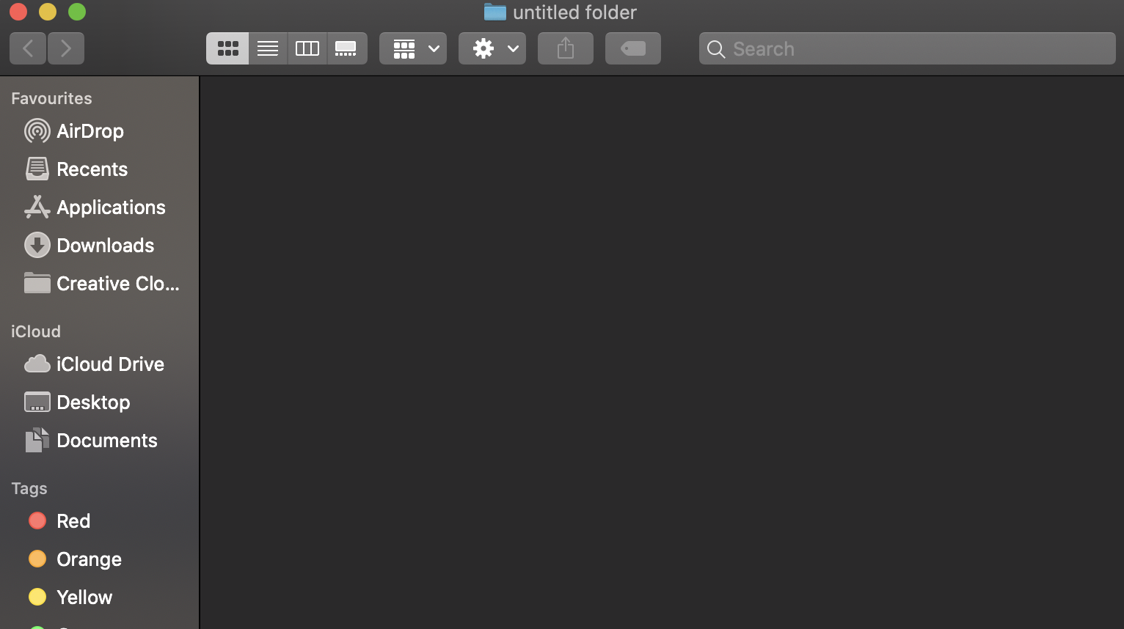

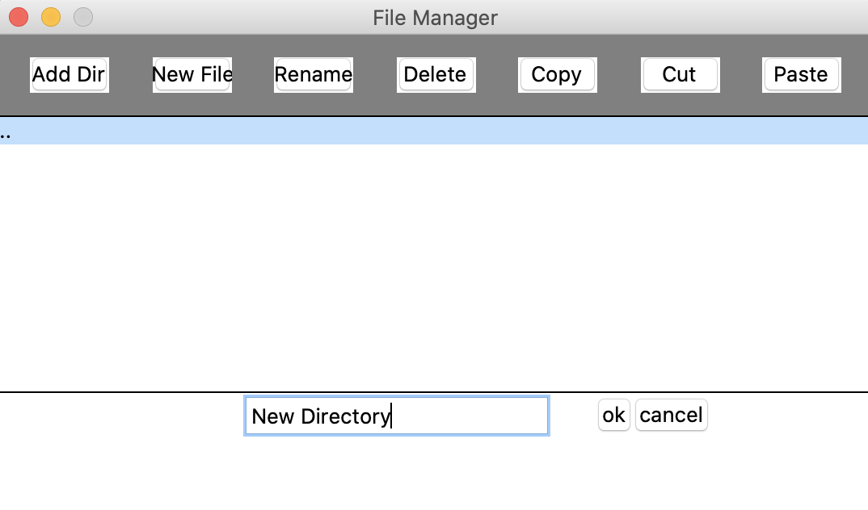

Folder after:

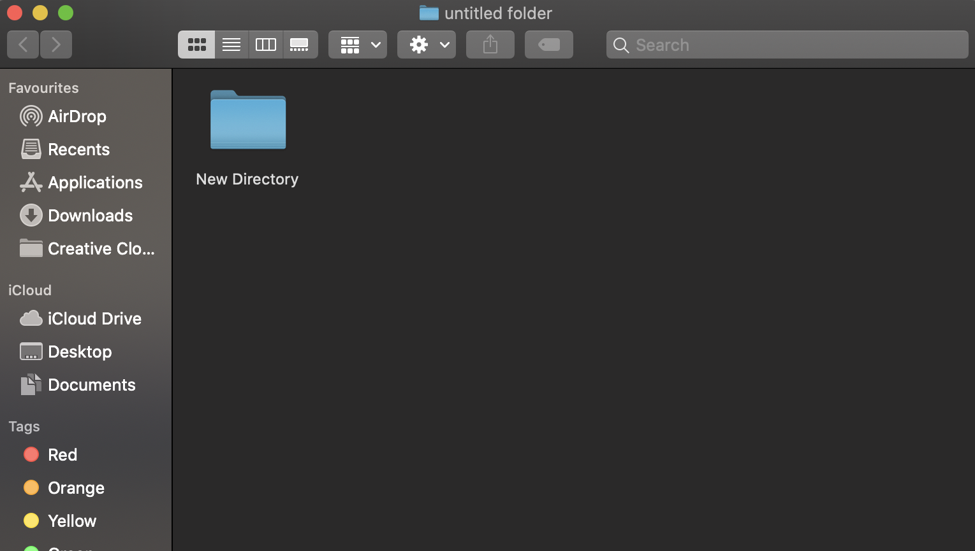

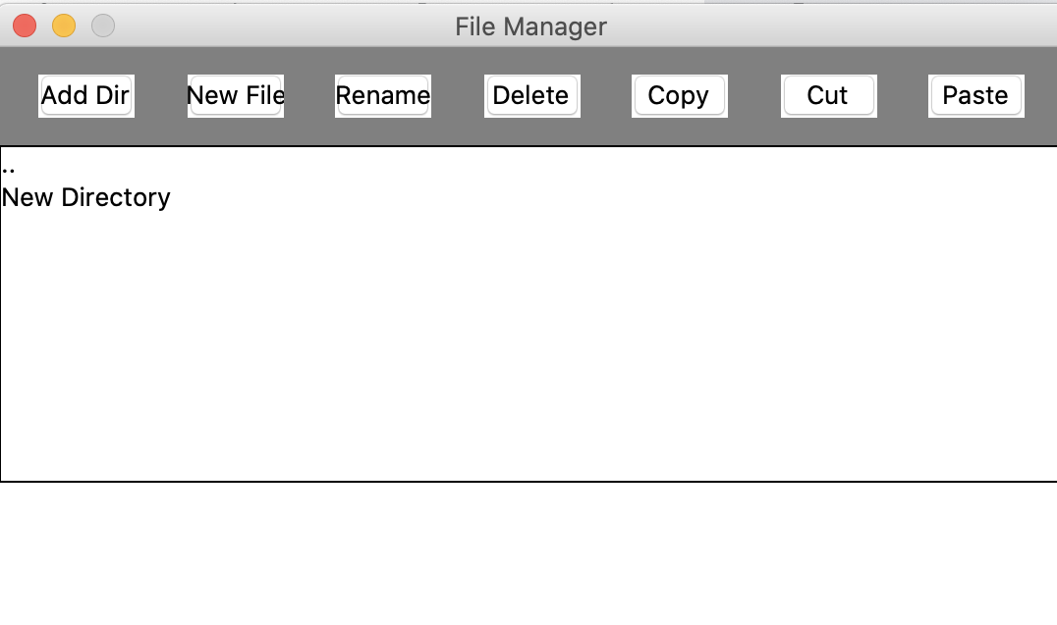

1. Adding a new file:

Before:



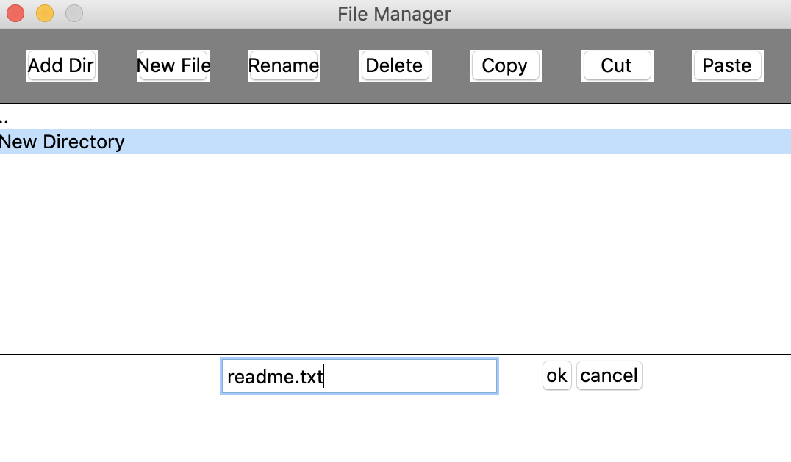

After:

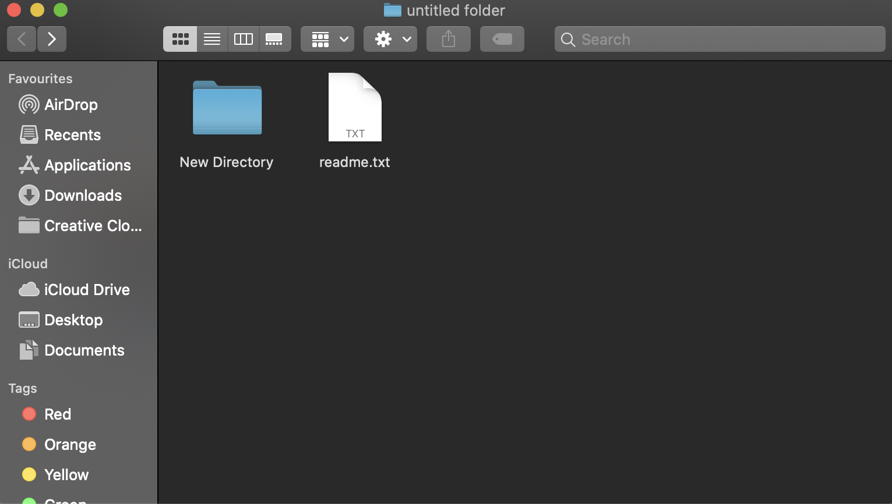

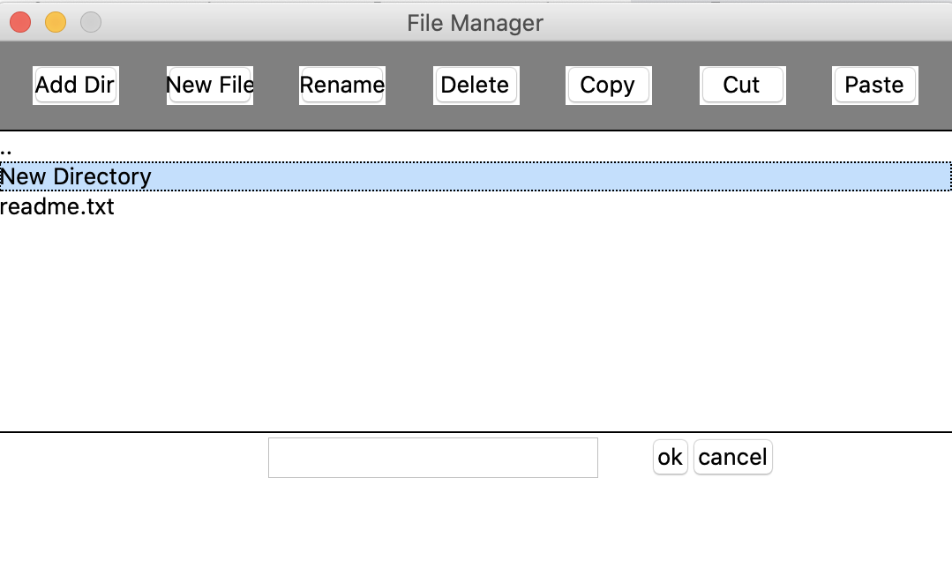

1. Renaming a file:

Before:



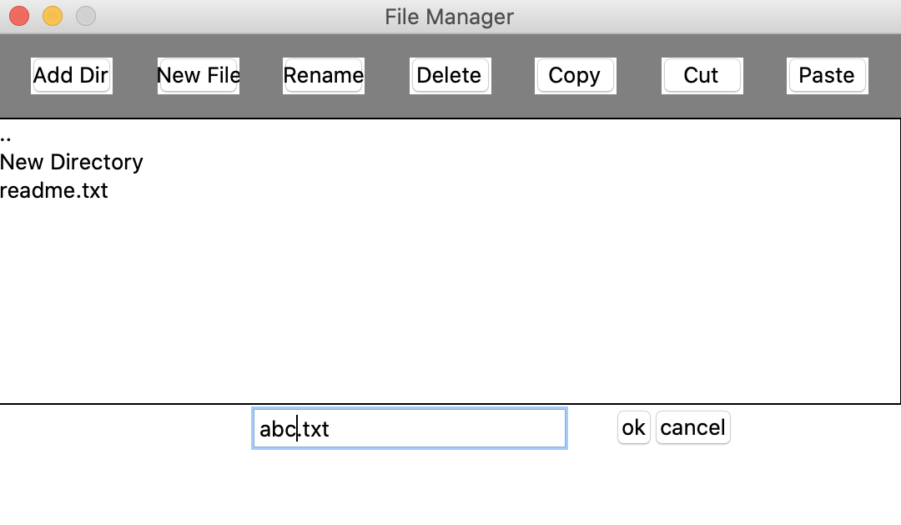

After:



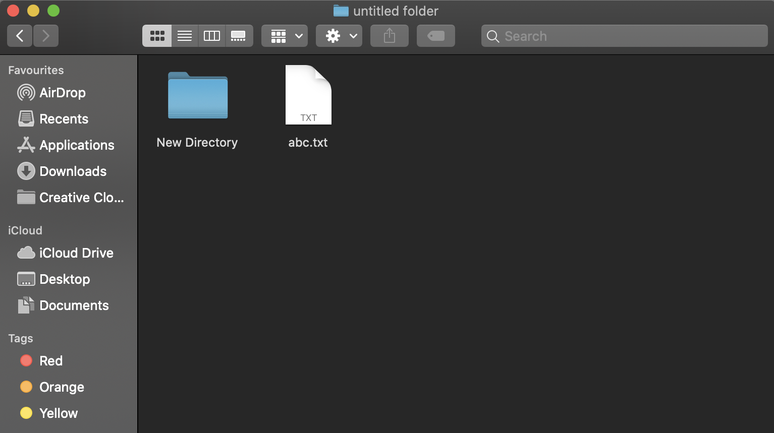

1. Deleting a file:

Before:



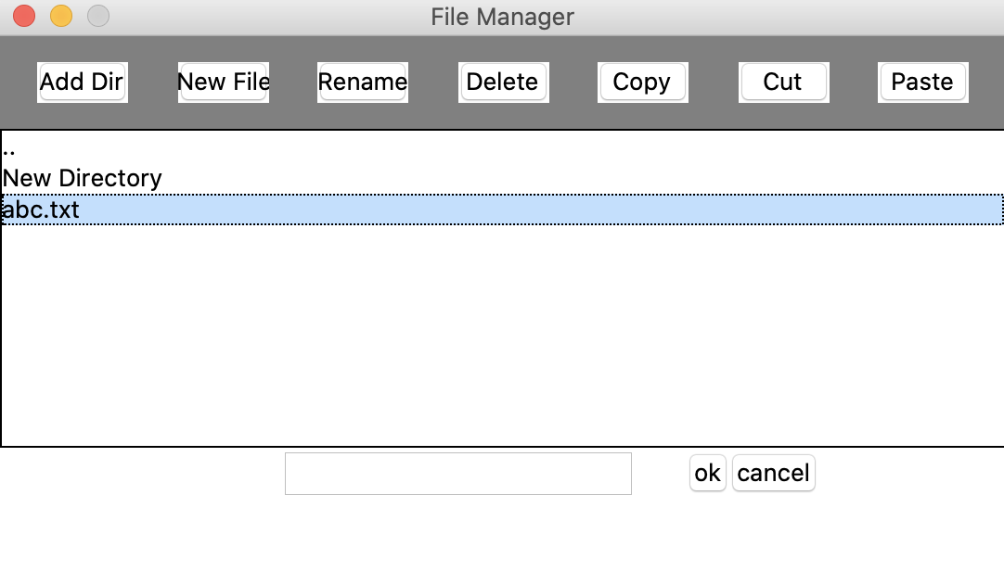

After:

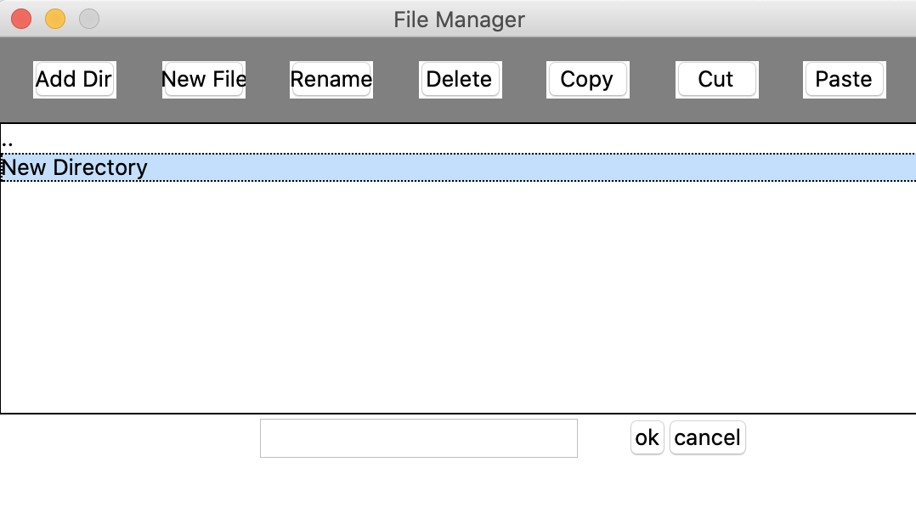

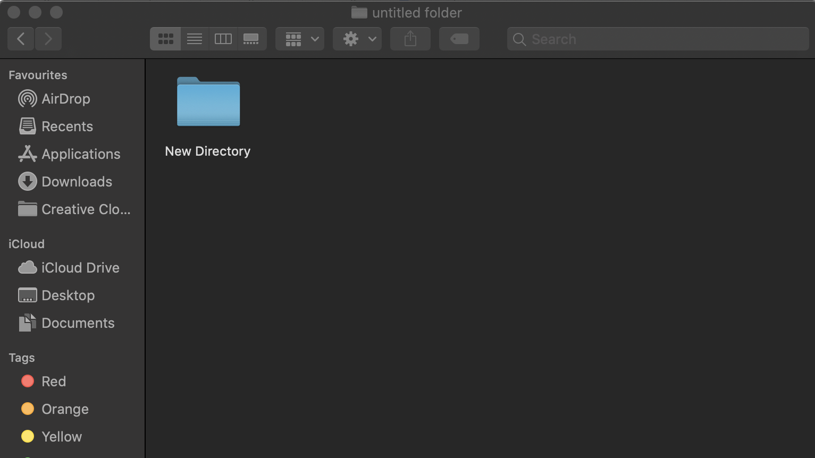

1. Copying a file:

Before:

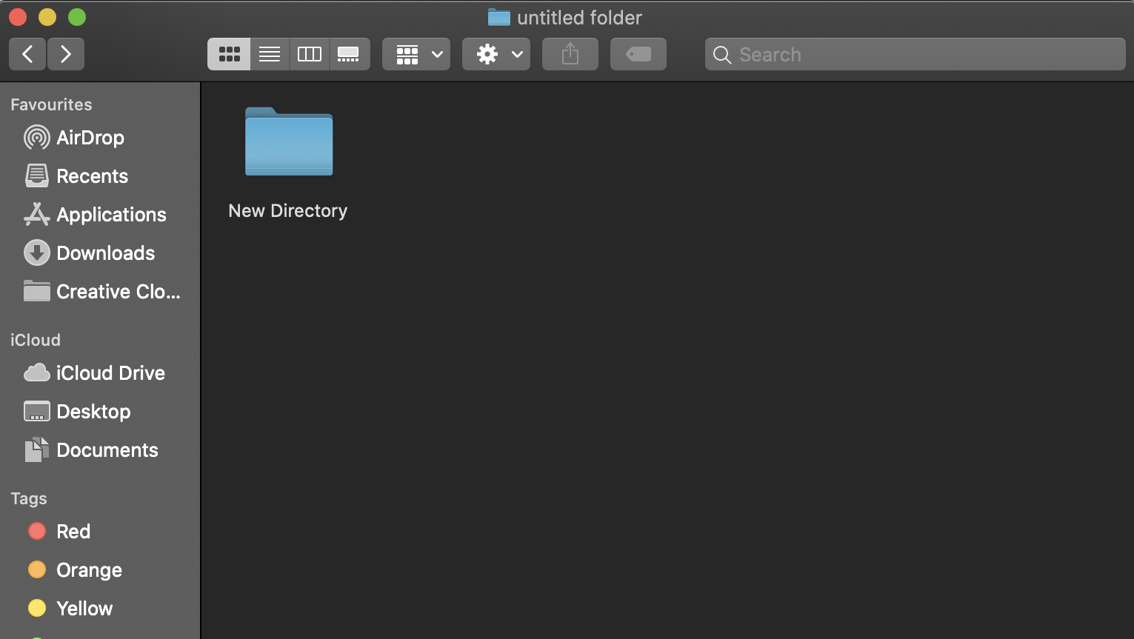

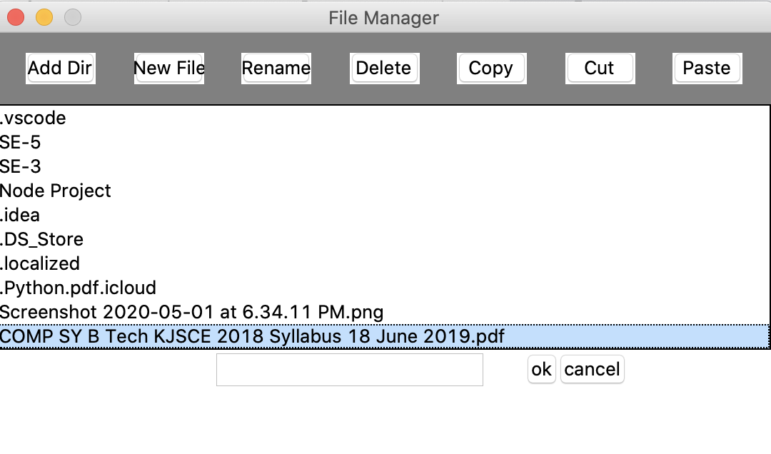

After:

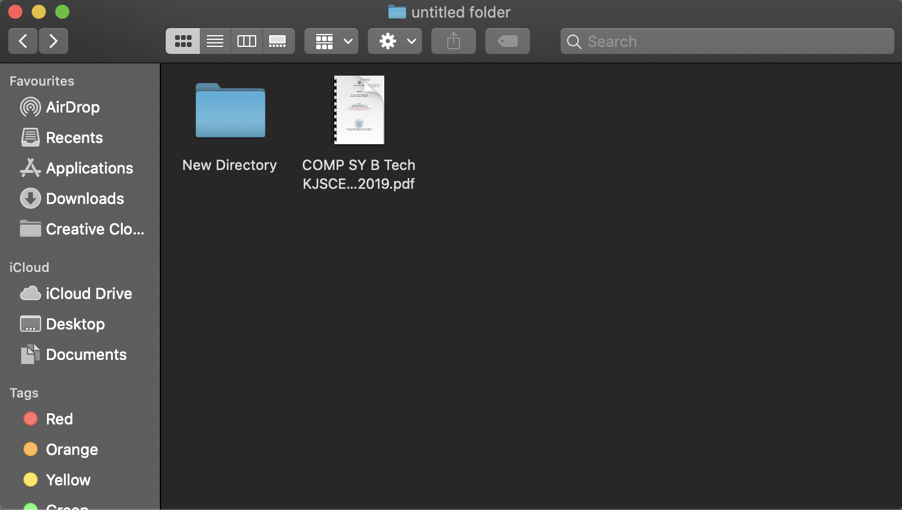

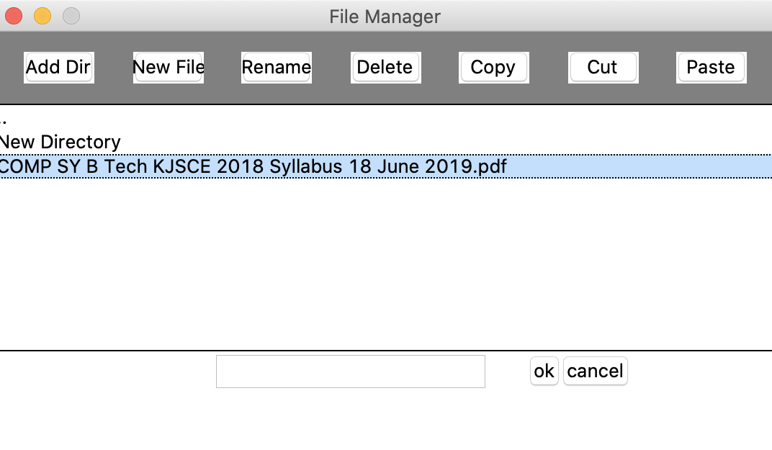

1. Cutting a file:

Before:





After:

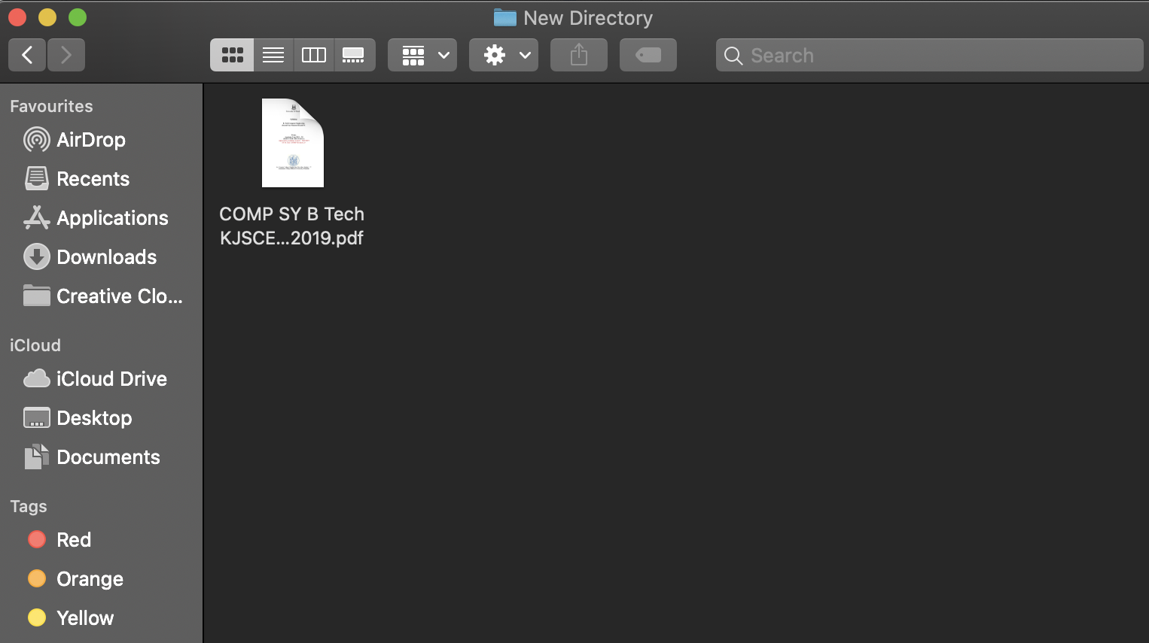

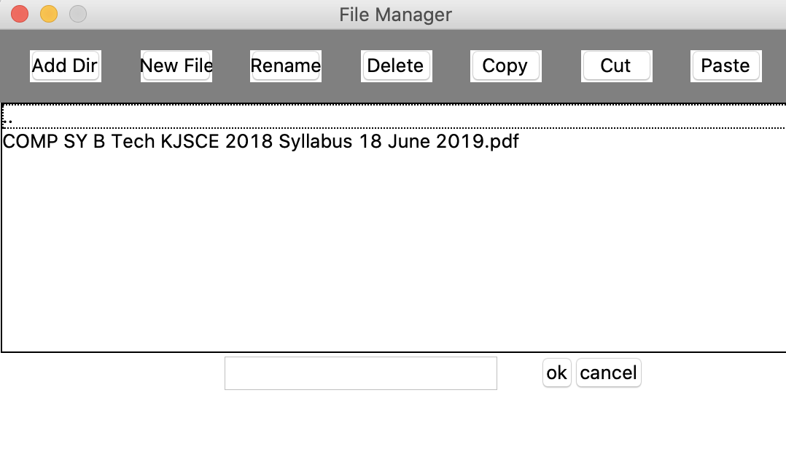

## Conclusion

These are the functions that can be performed using the local file manager.